DBMS ASSIGNMENT 4
ER Modeling & Relational Model
Local Case Study – Clinic Management System

Student Name | Sasanka Sekhar Kundu
Course | B.Tech
Unit / Chapter | Unit 1 – DBMS Fundamentals
Topic | ER Modeling & Relational Model
Database | PostgreSQL
Database Name | dbms_assignment_4

1. Objective
The objective of this assignment is to study a clinic's patient-intake process and translate the observed real-world process into an Entity–Relationship (ER) model and then into a physical relational model. The implementation is demonstrated using PostgreSQL with appropriate primary keys, foreign keys and sample records.

2. Case Study: Clinic Patient-Intake Process
The case study models a small clinic where patients register, doctors are assigned to appointments, consultations record diagnosis and notes, prescriptions are issued, medicines are linked to prescriptions, and billing records consultation and medicine charges.
- Patient registration stores name, contact number, age, gender and address.
- Doctors are recorded with name, specialization and contact number.
- Patients book appointments with doctors for a date and time.
- Completed appointments may result in a consultation containing diagnosis and notes.
- A consultation can create prescriptions, and prescriptions can contain multiple medicines.
- Billing records consultation fees, medicine fees, total amount and payment status.

3. Entities and Attributes
Entity | Attributes
Patient | patient_id (PK), patient_name, contact_number, age, gender, address
Doctor | doctor_id (PK), doctor_name, specialization, contact_number
Appointment | appointment_id (PK), patient_id (FK), doctor_id (FK), appointment_date, appointment_time, status
Consultation | consultation_id (PK), appointment_id (FK), patient_id (FK), doctor_id (FK), consultation_date, diagnosis, notes
Prescription | prescription_id (PK), consultation_id (FK), patient_id (FK), doctor_id (FK), prescription_date
Medicine | medicine_id (PK), medicine_name, dosage, price
Prescription_Medicine | prescription_medicine_id (PK), prescription_id (FK), medicine_id (FK), quantity, duration, instructions
Billing | bill_id (PK), patient_id (FK), appointment_id (FK), consultation_fee, medicine_fee, total_amount, payment_status

4. Relationships and Cardinality
Relationship | Cardinality | Meaning
Patient — Books — Appointment | 1 : N | One patient can book many appointments; each appointment belongs to one patient.
Doctor — Assigned to — Appointment | 1 : N | One doctor can be assigned to many appointments; each appointment is assigned to one doctor.
Appointment — Results in — Consultation | 1 : 1 | A completed appointment can produce one consultation record.
Patient — Generates — Billing | 1 : N | A patient may have multiple billing records over time.
Doctor — Conducts — Consultation | 1 : N | A doctor can conduct many consultations.
Consultation — Creates — Prescription | 1 : N | A consultation may create one or more prescriptions.
Prescription — Includes — Prescription_Medicine | 1 : N | A prescription can contain multiple medicine line items.
Medicine — Referred by — Prescription_Medicine | 1 : N | One medicine can occur in many prescription line items.

5. Digital ER Diagram
The following digital ER diagram represents the clinic management system. Rectangles represent entities/tables, ovals represent attributes, diamonds represent relationships, and 1/N labels show cardinality. Primary keys are underlined in the diagram.
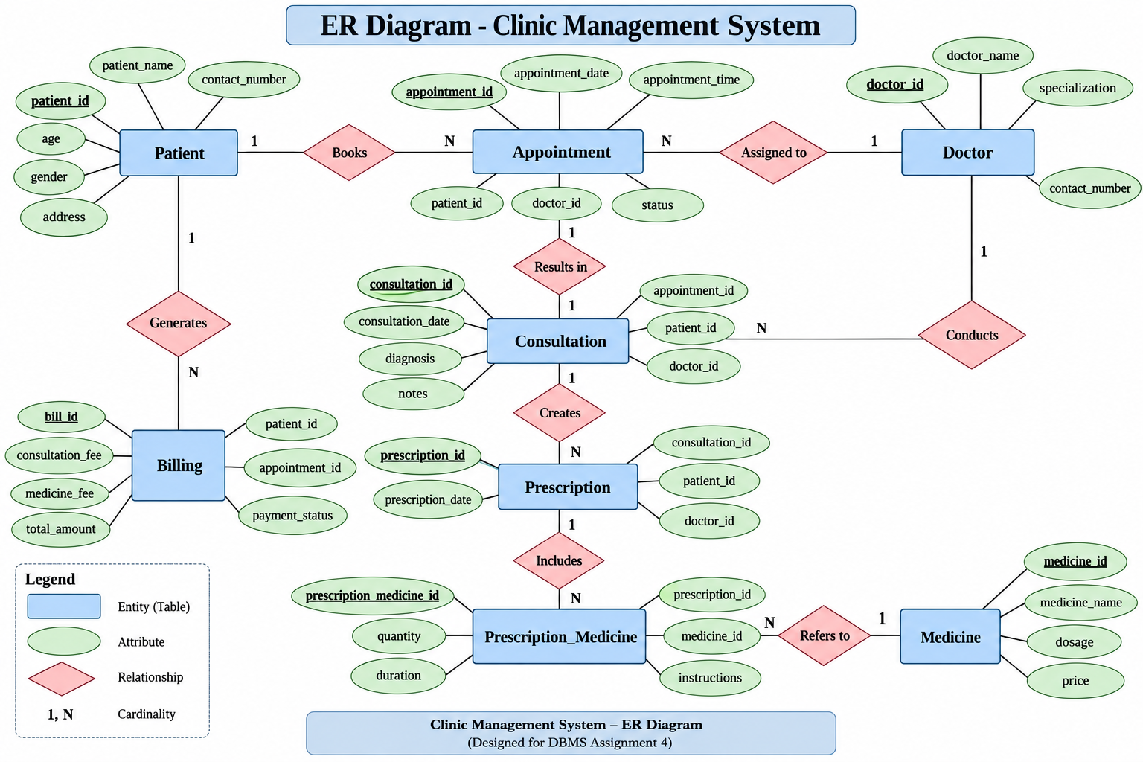
Figure 1: Digital ER Diagram – Clinic Management System

6. PostgreSQL Relational Model Implementation
The ER model was mapped into the PostgreSQL database dbms_assignment_4. Foreign keys enforce the relationships between the tables. The many-to-many relationship between Prescription and Medicine is resolved through the Prescription_Medicine table.
CREATE TABLE patients (
patient_id SERIAL PRIMARY KEY,
patient_name VARCHAR(100) NOT NULL,
contact_number VARCHAR(15),
age INT,
gender VARCHAR(20),
address VARCHAR(200)
);
CREATE TABLE doctors (
doctor_id SERIAL PRIMARY KEY,
doctor_name VARCHAR(100) NOT NULL,
specialization VARCHAR(100),
contact_number VARCHAR(15)
);
CREATE TABLE appointments (
appointment_id SERIAL PRIMARY KEY,
patient_id INT NOT NULL REFERENCES patients(patient_id),
doctor_id INT NOT NULL REFERENCES doctors(doctor_id),
appointment_date DATE NOT NULL,
appointment_time TIME NOT NULL,
status VARCHAR(30) DEFAULT 'Scheduled'
);
CREATE TABLE consultations (
consultation_id SERIAL PRIMARY KEY,
appointment_id INT NOT NULL REFERENCES appointments(appointment_id),
patient_id INT NOT NULL REFERENCES patients(patient_id),
doctor_id INT NOT NULL REFERENCES doctors(doctor_id),
consultation_date DATE NOT NULL,
diagnosis VARCHAR(200),
notes VARCHAR(500)
);
CREATE TABLE prescriptions (
prescription_id SERIAL PRIMARY KEY,
consultation_id INT NOT NULL REFERENCES consultations(consultation_id),
patient_id INT NOT NULL REFERENCES patients(patient_id),
doctor_id INT NOT NULL REFERENCES doctors(doctor_id),
prescription_date DATE NOT NULL
);
CREATE TABLE medicines (
medicine_id SERIAL PRIMARY KEY,
medicine_name VARCHAR(100) NOT NULL,
dosage VARCHAR(100),
price NUMERIC(10,2)
);
CREATE TABLE prescription_medicines (
prescription_medicine_id SERIAL PRIMARY KEY,
prescription_id INT NOT NULL REFERENCES prescriptions(prescription_id),
medicine_id INT NOT NULL REFERENCES medicines(medicine_id),
quantity INT NOT NULL,
duration VARCHAR(50),
instructions VARCHAR(200)
);
CREATE TABLE billing (
bill_id SERIAL PRIMARY KEY,
patient_id INT NOT NULL REFERENCES patients(patient_id),
appointment_id INT NOT NULL REFERENCES appointments(appointment_id),
consultation_fee NUMERIC(10,2) DEFAULT 0,
medicine_fee NUMERIC(10,2) DEFAULT 0,
total_amount NUMERIC(10,2) NOT NULL,
payment_status VARCHAR(30) DEFAULT 'Pending'
);

7. PostgreSQL Execution Evidence
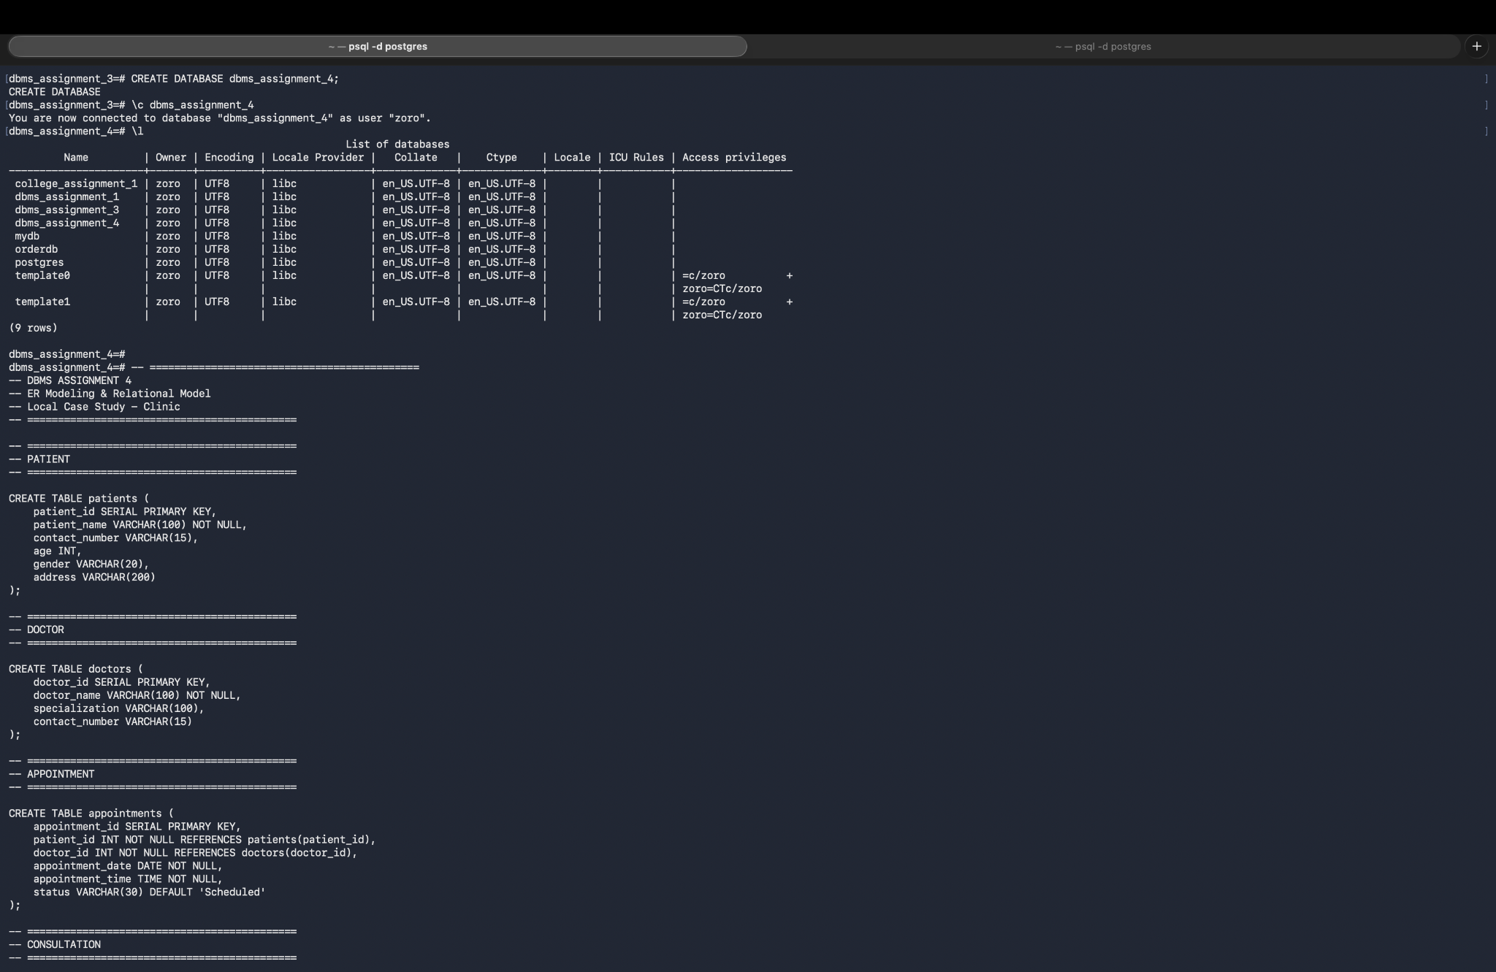
Figure 2: Database creation and table definitions executed successfully.
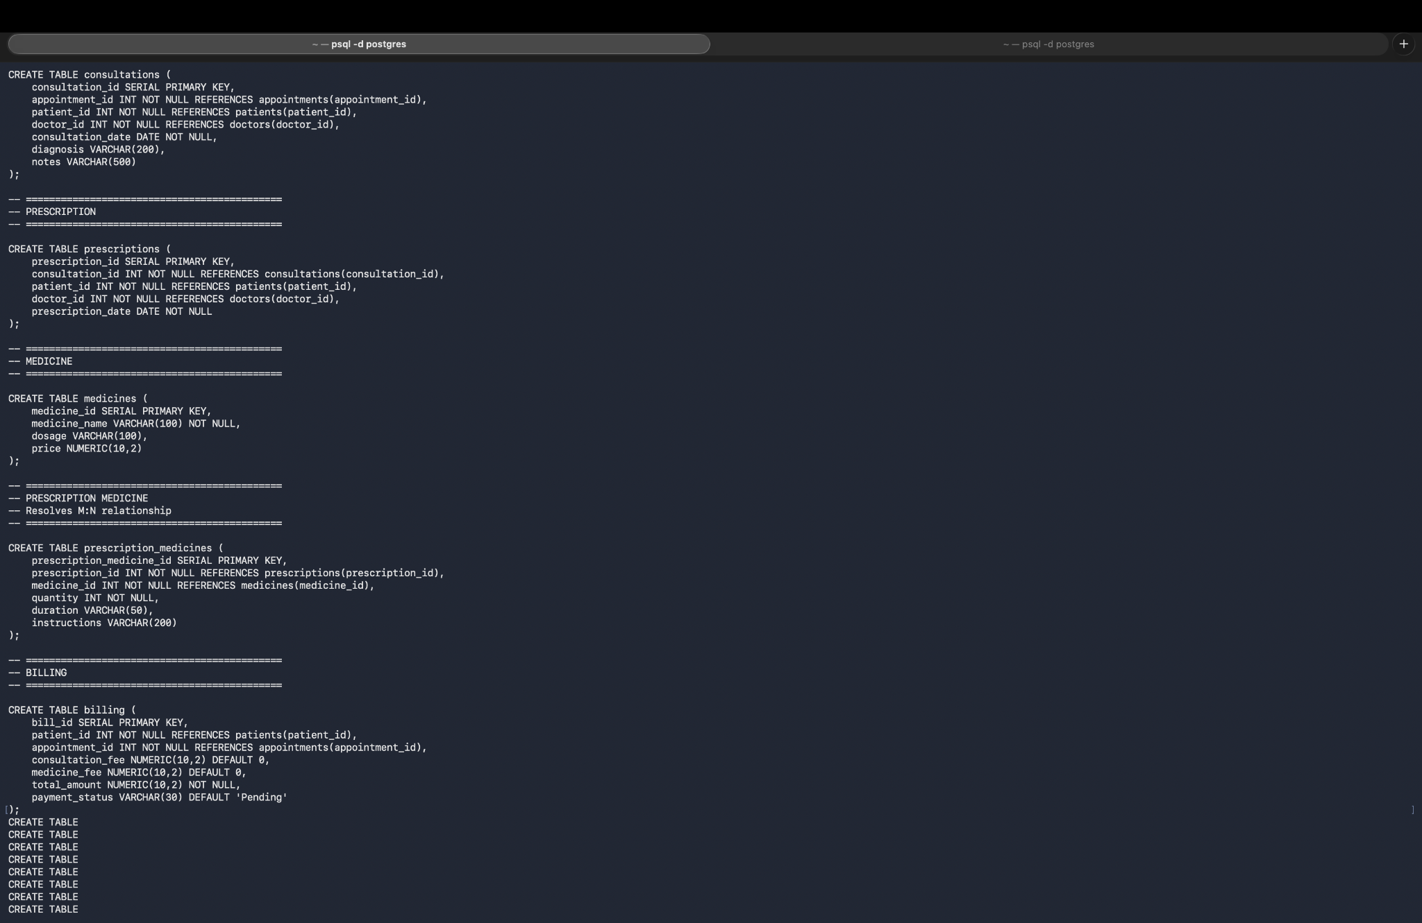
Figure 3: Doctors, patients, appointments and consultation records.
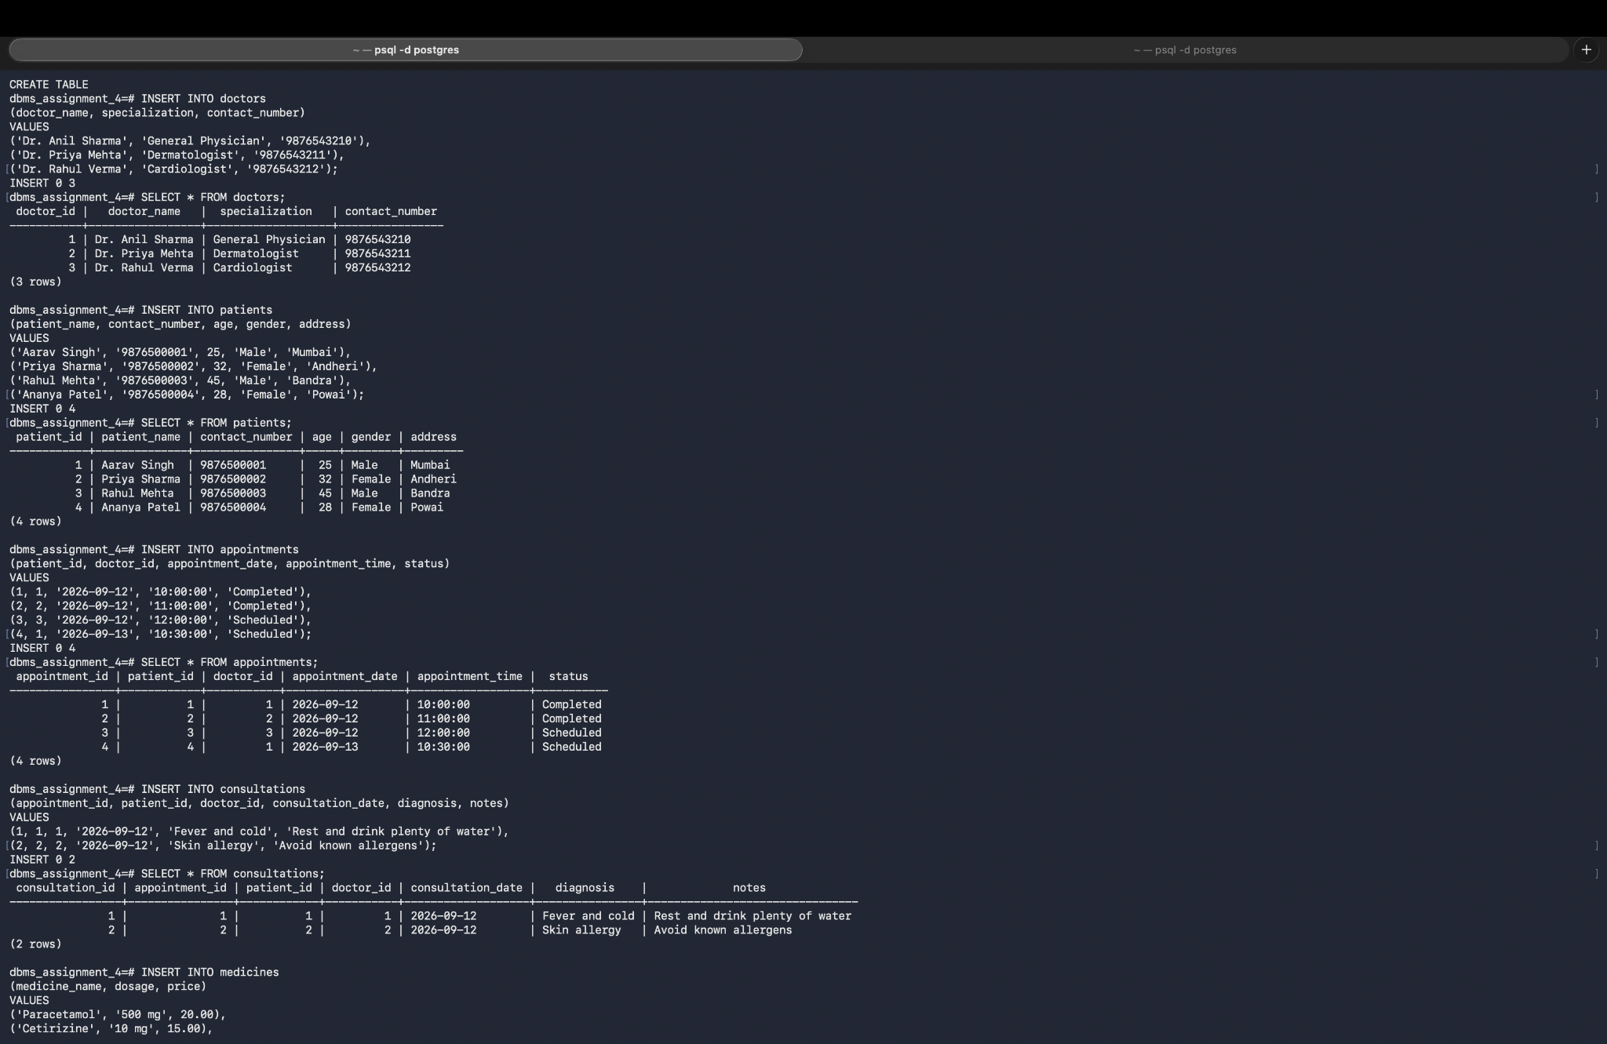
Figure 4: Medicines, prescriptions, prescription-medicine records and billing.
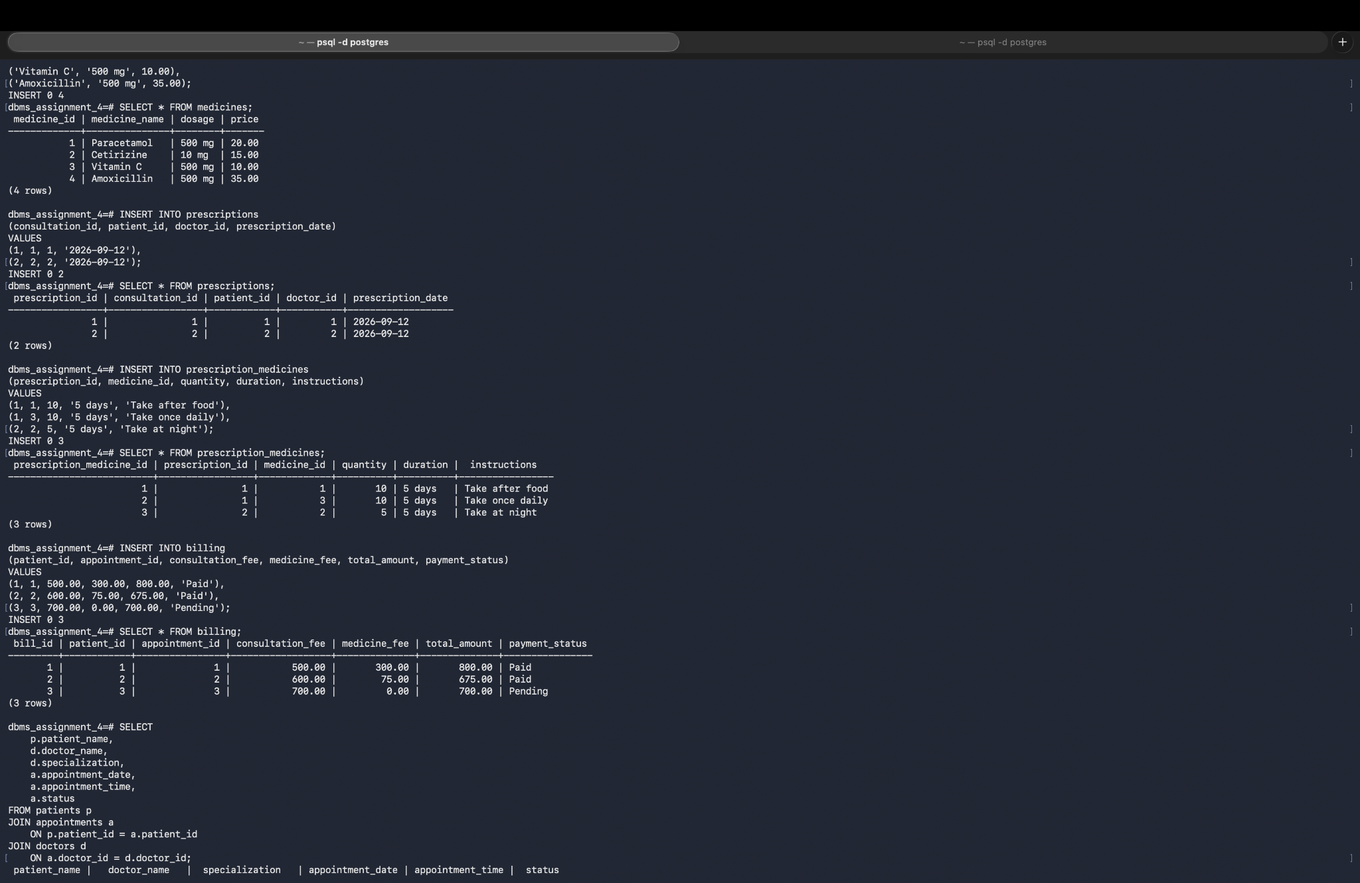
Figure 5: JOIN query showing patients, doctors and appointment details.
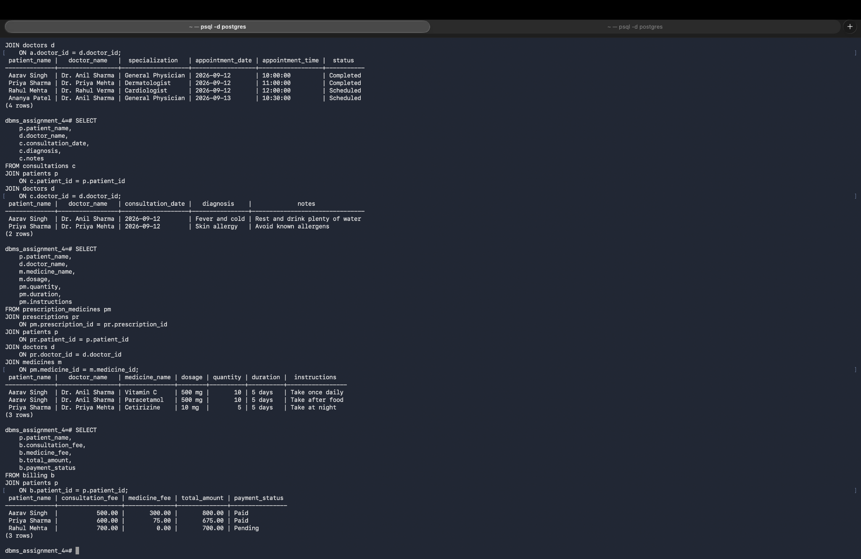
Figure 6: JOIN query showing consultation, prescription/medicine and billing information.

8. Relational Schema / Physical Model
- PATIENTS(patient_id PK, patient_name, contact_number, age, gender, address)
- DOCTORS(doctor_id PK, doctor_name, specialization, contact_number)
- APPOINTMENTS(appointment_id PK, patient_id FK → PATIENTS.patient_id, doctor_id FK → DOCTORS.doctor_id, appointment_date, appointment_time, status)
- CONSULTATIONS(consultation_id PK, appointment_id FK → APPOINTMENTS.appointment_id, patient_id FK → PATIENTS.patient_id, doctor_id FK → DOCTORS.doctor_id, consultation_date, diagnosis, notes)
- PRESCRIPTIONS(prescription_id PK, consultation_id FK → CONSULTATIONS.consultation_id, patient_id FK → PATIENTS.patient_id, doctor_id FK → DOCTORS.doctor_id, prescription_date)
- MEDICINES(medicine_id PK, medicine_name, dosage, price)
- PRESCRIPTION_MEDICINES(prescription_medicine_id PK, prescription_id FK → PRESCRIPTIONS.prescription_id, medicine_id FK → MEDICINES.medicine_id, quantity, duration, instructions)
- BILLING(bill_id PK, patient_id FK → PATIENTS.patient_id, appointment_id FK → APPOINTMENTS.appointment_id, consultation_fee, medicine_fee, total_amount, payment_status)
For the required physical activity, each of the eight relations can be written on a separate index card. Underline or clearly mark the PK on each card. Use yarn/string to connect each FK to the referenced PK and label the string with the FK mapping, for example Appointment.patient_id → Patient.patient_id.

9. Sample SQL Queries and Verification
Query 1
SELECT p.patient_name, d.doctor_name, d.specialization,
a.appointment_date, a.appointment_time, a.status
FROM patients p
JOIN appointments a ON p.patient_id = a.patient_id
JOIN doctors d ON a.doctor_id = d.doctor_id;
Query 2
SELECT p.patient_name, d.doctor_name, c.consultation_date,
c.diagnosis, c.notes
FROM consultations c
JOIN patients p ON c.patient_id = p.patient_id
JOIN doctors d ON c.doctor_id = d.doctor_id;
Query 3
SELECT p.patient_name, d.doctor_name, m.medicine_name,
m.dosage, pm.quantity, pm.duration, pm.instructions
FROM prescription_medicines pm
JOIN prescriptions pr ON pm.prescription_id = pr.prescription_id
JOIN patients p ON pr.patient_id = p.patient_id
JOIN doctors d ON pr.doctor_id = d.doctor_id
JOIN medicines m ON pm.medicine_id = m.medicine_id;
Query 4
SELECT p.patient_name, b.consultation_fee, b.medicine_fee,
b.total_amount, b.payment_status
FROM billing b
JOIN patients p ON b.patient_id = p.patient_id;

10. Mapping ER Model to Relational Model
Entity | Table | Primary Key
Patient | patients | patient_id
Doctor | doctors | doctor_id
Appointment | appointments | appointment_id
Consultation | consultations | consultation_id
Prescription | prescriptions | prescription_id
Medicine | medicines | medicine_id
Prescription_Medicine | prescription_medicines | prescription_medicine_id
Billing | billing | bill_id

11. Result
The clinic patient-intake process was successfully modeled using an ER diagram and converted into a relational schema. The PostgreSQL implementation contains eight related tables with primary and foreign keys. Sample records and JOIN queries demonstrate that the relationships can be used to retrieve patient, doctor, appointment, consultation, prescription, medicine and billing information.

12. Conclusion
This assignment demonstrates the complete database-design flow from a real-world clinic process to conceptual ER modeling and finally to a relational database implementation. The use of primary keys provides unique identification of records, while foreign keys maintain relationships and referential integrity. The Prescription_Medicine table correctly resolves the many-to-many relationship between prescriptions and medicines. PostgreSQL provides a practical platform for testing and verifying the relational model.

13. Submission Checklist
- Digital ER diagram exported/saved as PNG or PDF.
- Physical index-card-and-yarn relational model prepared and photographed.
- Each table card contains its table name, columns and clearly marked primary key.
- Foreign-key strings are labelled with the FK → referenced PK mapping.
- PostgreSQL database dbms_assignment_4 contains the implemented relational model.
- Interview/observation details should be completed from the student's actual clinic visit and permission obtained.

